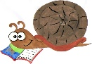
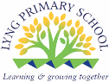
Lyng Primary School Knowledge Organiser

History Topic: | Mayans | Year 4  Buildings, Battles and Beliefs | Spring
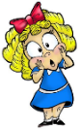

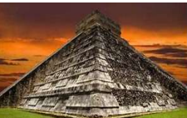

Let’s recap…
Spelling | Definition
Archaic | Extremely old or old-fashioned.
Astrology | Is the study of the movements of the planets, sun, moon, and stars in the belief that these movements can have.
Astronomy | The scientific study of the stars, planets, and other natural objects in space.
Deity | A God or Goddess.
Hierarchy | A hierarchy is a system of organising people into different ranks or levels of importance, for example in society or in a company.
High priest | At the third position in the hierarchy of Mayan politics was the high priest. The high priest lead a hierarchy of priests. He was also responsible for foretelling auspicious events for the rules and finding the dates of ceremonies and festivals.
Maya | a member of an indigenous people of Yucatan, Belize and Guatemala, having an ancient culture once characterised by outstanding achievements in architecture, astronomy, chronology, painting and pottery.
Mayan | Of, relating to, or characteristic of the Maya or any of their languages.  A family of Central American languages.
Mesoamerica | Another name for Central America.
Pagan | Pagan beliefs and activities do not belong to any of the main religions of the world and take nature and a belief in many Gods as a basis.
Temple | A building used for the worship of a God or Gods.
Sacrifice | To sacrifice an animal or person means to kill them in a special religious ceremony as an offering to a God.

- Year 1 – Children looked at the Amazon Rainforest and how chocolate was made.
- Year 2 – Children learnt about significant places and people from across the world and their impact on our lives today.
- Year 3 – children looked at the early civilisation in Ancient Egypt.

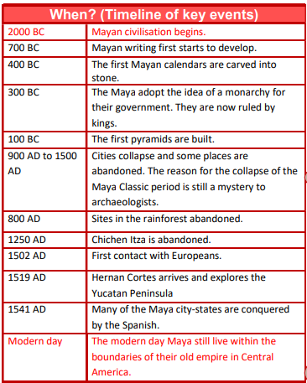
HOOK
Write a recount of our trip to Cadbury World.
What did we learn about the Mayans?
TRIP/VISITOR
Cadbury World

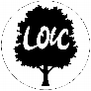
To discover more:
BBC Bitesize - https://www.bbc.co.uk/bitesize/articles/z2pmvj6
Britannica Kids - https://kids.britannica.com/kids/article/Maya/353445

Our Storytelling Approach to enhance engagement

People:  Mayan tribe | 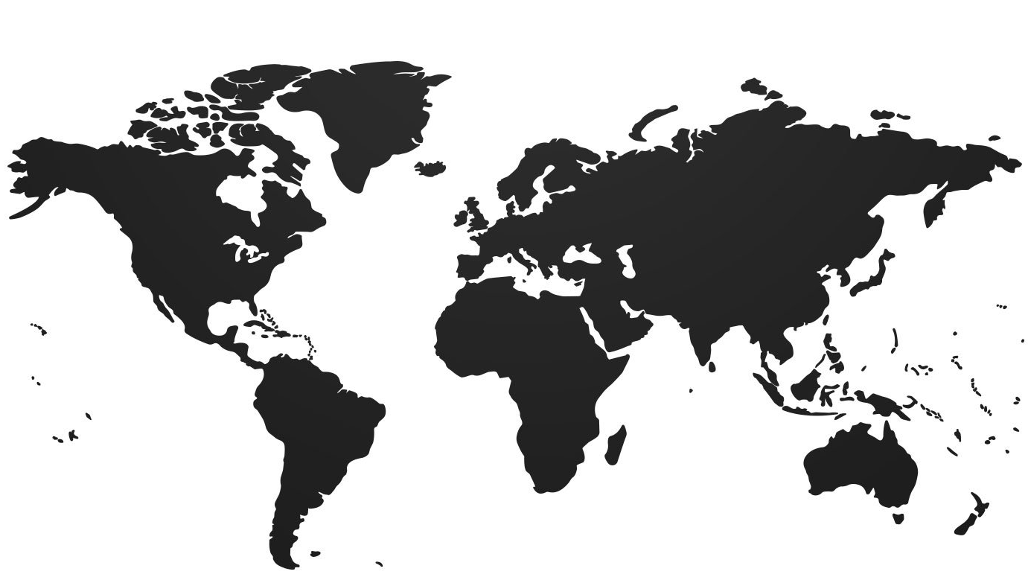Place:  Mexico and Central America | Problem:  Should I be sacrificed to the Gods?
Maya Gods- The Maya believed in a large number of nature gods. Some gods were considered more important and powerful than others.
Itzamna - The most important Maya god was Itzamna. Itzamna was the god of fire who created the Earth. He was ruler of heaven as well as day and night. The Maya believed that he gave them the calendar and writing. It is thought that his name means "lizard house".
Kukulkan - Kukulkan was a powerful snake god whose name means "feathered serpent". He was the primary god of the Itza people in the latter part of the Maya civilization. He is often drawn to look like a dragon.
Chaac - Chaac was the god of rain and lightning. He had a lighting axe that he used to strike the clouds and produce rain and storms.
Divine Kings The kings of the Maya served as intermediaries between the people and the gods. In some ways the kings were thought to be gods themselves.
Priests- The priests were responsible for performing rituals to keep the people in the favor of the gods. They were very powerful. In the Book of the Jaguar Priest, the duties of the priests are described in detail.
Key Facts and Famous Figures
Focus Text

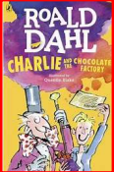

Enquiry questions (sequence of learning) that we shall investigate during the topic:
- Who were the Mayans and when did they live?
- How did Mayan homes compare to others?
- What beliefs did the Mayans have?
- What was the Mayan number system?

Agreed Outcome
To understand the beliefs of the Mayans and their Pagan views.
To understand how the Spanish invasion has influenced the current Maya culture.

Lyng Primary School Knowledge Quiz

History Topic: | Mayan | Year 4  Buildings, Battles and Beliefs | Spring
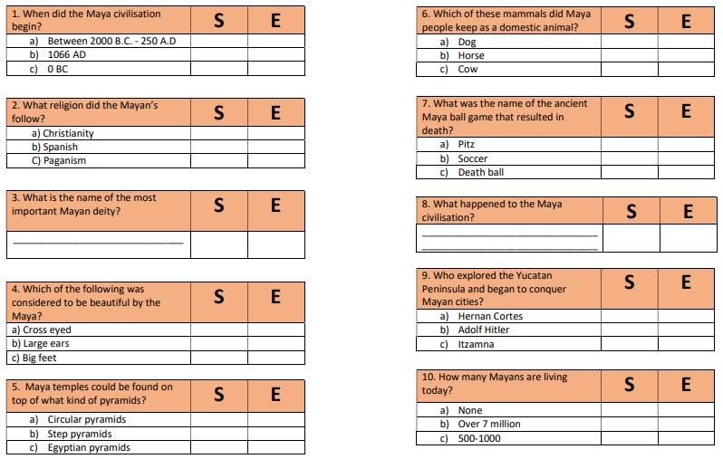

Our Mayan
Quick Quiz

